**Installation Guide for the Trader Desktop Tool app in**

**Google Chrome**

**Step 1: Open Google Chrome and go to extension or type chrome://extensions/ in the url bar.**

**Step 2: Enable the developer mode**

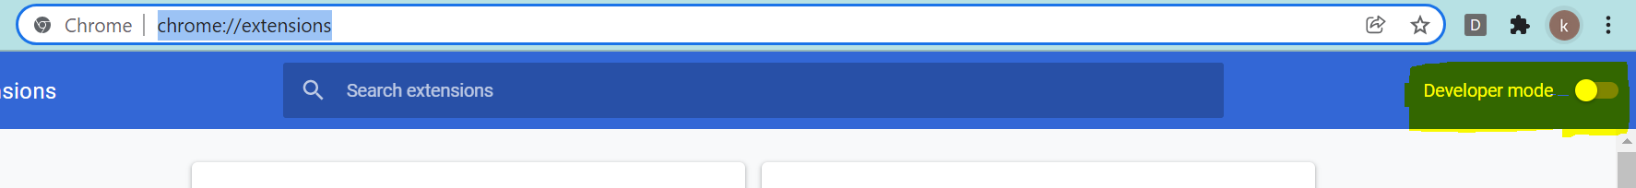

**Step 3: Click the Load unpacked button**



**Step 4: Select the folder/location in the computer on which the code available**

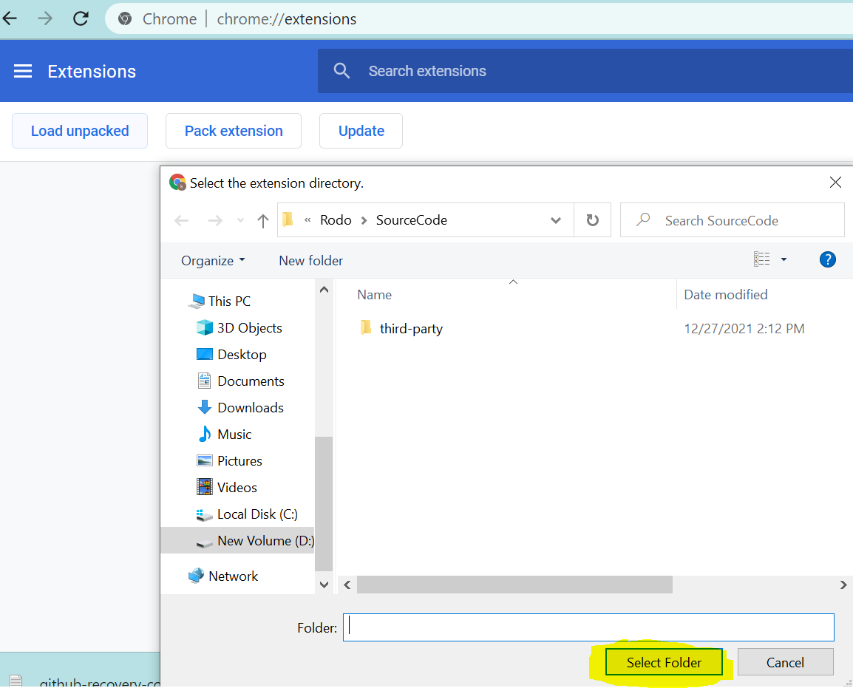

**Step 5: After selecting the folder now we see the extension deployed in chrome**

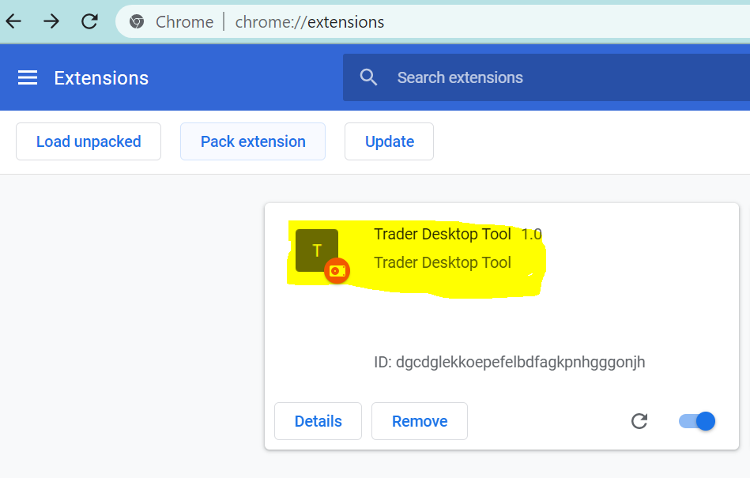

**Step 6: To make the tool appear near the url bar, select the extension button on the left end of the url bar and pin the application.**

